Soul Group Dowsing Chart

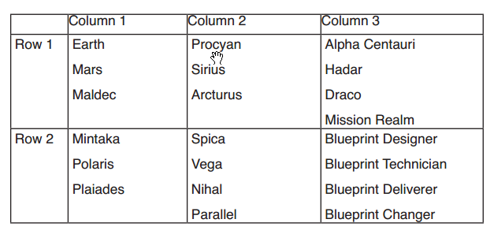

To use this dowsing chart, you would ask “Is [Client’s] Soul Group located in Column 1? Column 2?” Etc. until you receive a “yes” answer.
Now that you have established the column, you would ask “Is Client’s Soul Group located in Row 1? (If no) Row 2?”
Now that you have the column and row identified, you can dowse through the individual Soul Groups located in that specific chart section.

Energies Chart
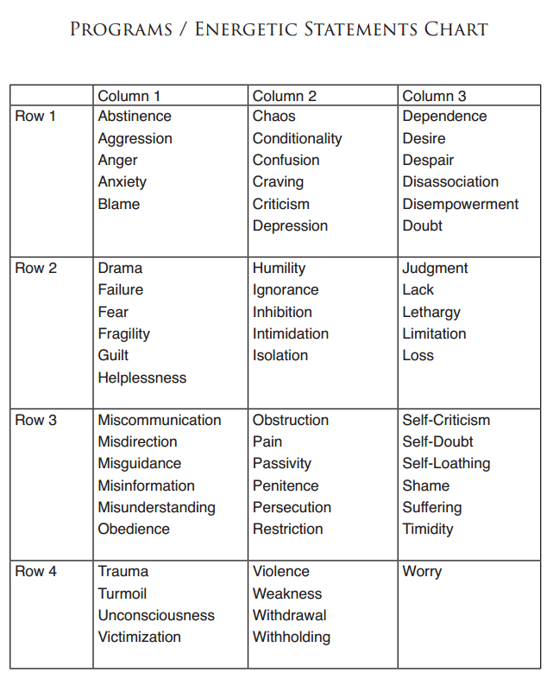

Grouping Karmic Patterns

First, create several columns on the back of your session sheet and label them “Pattern #1, Pattern #2, etc.”
Start with the first block / restriction you uncovered (which might be Godspark damage, or a negative Guide, or Golden Web damage ...) and write it down under “Pattern #1.”
Go to the next block / restriction on your session sheet that you uncovered for the client and ask:
“Is this [NAME IT] part of Pattern #1? Or is it part of a separate pattern?”
If separate, put it under “Pattern #2.”
Go to the next block / restriction you found for the client and ask:
“Is this [NAME IT] part of Pattern #1? Pattern #2? Or is it part of a separate pattern?”
Every time you find a block and restriction that isn’t part of an existing pattern ... start a new pattern!
Sometimes you will end up with just two patterns that contain four or five blocks and restrictions each. At other times, you will come up with five patterns, some of which have just a single block and restriction. Just keep your intention in mind - you are sorting blocks and restrictions into separate karmic patterns.
As long as your intention is clear, this is not a process that requires any thinking or pondering on your part. There is nothing to “figure out.” All you are asking is which puzzle pieces go together to form cohesive parts of the entire picture. I suggest you go through this process fairly quickly, so that your mind doesn’t have time to get too curious. Guessing what blocks and restrictions go together is not good for your accuracy!

Asking Questions: When

The first piece of information you can establish for each pattern is WHEN the negative karmic pattern was set into motion. Remember, we are grouping blocks and restrictions by lifetime.
- Is this negative karmic pattern a past-life or present-life pattern?
- (For past-life) How many lifetimes ago did my client instigate this negative karmic pattern?
- (For present-life) At what present-life age did my client instigate this negative karmic pattern?
Please note that we have not lived thousands or even hundreds of lifetimes. Most past-life patterns will most likely come from two to twenty lifetimes ago. Occasionally, you may find older past-life blocks and restrictions. I have yet to find any going back more than sixty lifetimes.
Remember, “past-life” refers to when the negative karmic pattern started Obviously it is still being continued by the client today, or it wouldn’t show up in their Record!
The best place to start your investigative process is with any root cause blocks
and restrictions present in the pattern.
Occasionally, you might have multiple root cause blocks and restrictions - you might find an implant, a vow, and a constraint along with a few Attaching Souls and Soul Loss, a Golden Web tear and memory issues.
In such cases, you’ll want to ask which of the root blocks came first - the implant, vow, or the constraint? That’s where you’ll want to start your investigative process.

Asking Questions: Who
Now that you know the WHEN, it’s time to investigate the WHO. For past-life issues, you’ll first of all want to find out:
• Was my client incarnated as male or female in that lifetime?
Remember that Souls can incarnate as either gender. Knowing the gender of your client will shape the perspective of the story. Obviously, this question is unnecessary for present-life issues!
For most past-life root cause blocks and restrictions, we next want to find out WHO the other people involved were!
Remember that we usually create any negative agreements and attachment mechanisms with actual people in our lives, usually those closest to us.
If you encounter blocks and restrictions that must, by definition, involve one or more other people, the next step is to find out the relationship our client had with those people in that lifetime.
For example, if you have a negative intention placed on the client three lifetimes ago, you’ll next want to find out who would have placed it. If you have three
Attaching Souls in that same issue, chances are that all three of them placed that negative intention!
On the other hand, you may only have one or even no Attaching Souls ... engage reason and logic.
Negative intentions most likely come from spouses, lovers, parents, siblings, our children, relatives or close friends. Occasionally they come from business associates. Think about whose opinion really matters to us!
If you have negative unjustified karma, the question is:
“Who did my client cause harm, or have the perception of causing harm?”
Again, we just don’t create negative unjustified karma with total strangers, nor do we usually have the occasion to mistakenly do harm to strangers. Instead, we might mistakenly hurt those closest to us through neglect or inattention, or simple lack of awareness.
If you encounter a constraint, you know that your client surrendered their free will to someone. That someone would obviously be a perceived authority figure. We don’t surrender our free will to someone whose authority we don’t believe in.
For an implant, the “who” is usually an organization of some kind - military, political, religious, social, educational, financial ... there’s not that many options. This kind of logical thinking will help you come up with who else played a role in your client’s negative choices.

